1999

COMPREHENSIVE INTEGRATED

MENTAL HEALTH PLAN

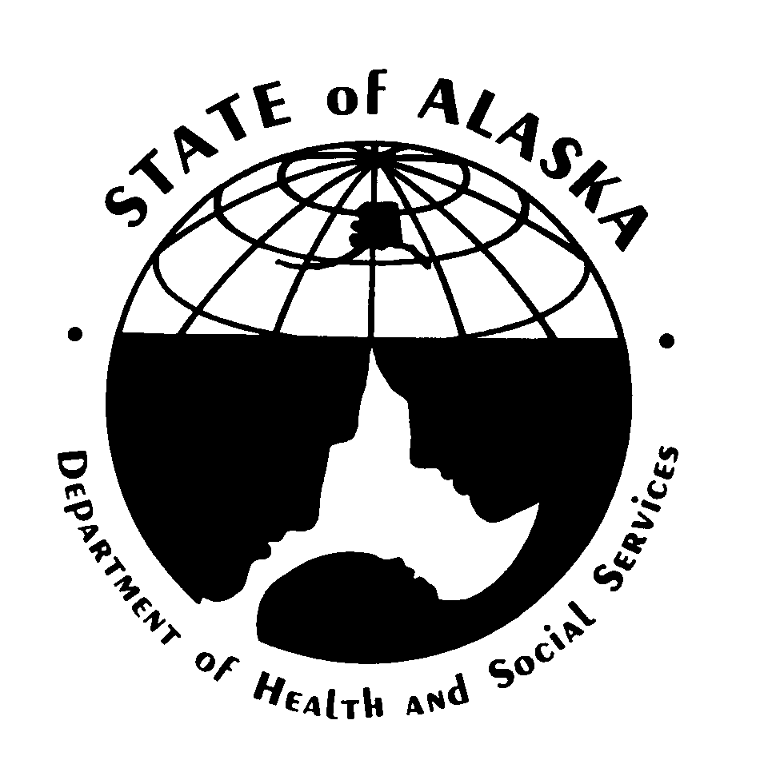

Tony Knowles, Governor
State of Alaska

Karen Perdue, Commissioner
Alaska Department of Health and Social Services

June, 1999

